1. The website, <http://arngren.net/> which sells a variety of gadgets is absolutely terrible. It violates all six principles of user interface design. First of all, the layout is atrocious. All the site’s products are just crammed on the home page. There’s no rhyme or reason to any of the design. That being said, content awareness is also very poor. Looking at the site gives you a headache, it’s not inviting whatsoever. The site is consistent in one way - It confusing throughout, and requires substantial effort from the end user to navigate/use.

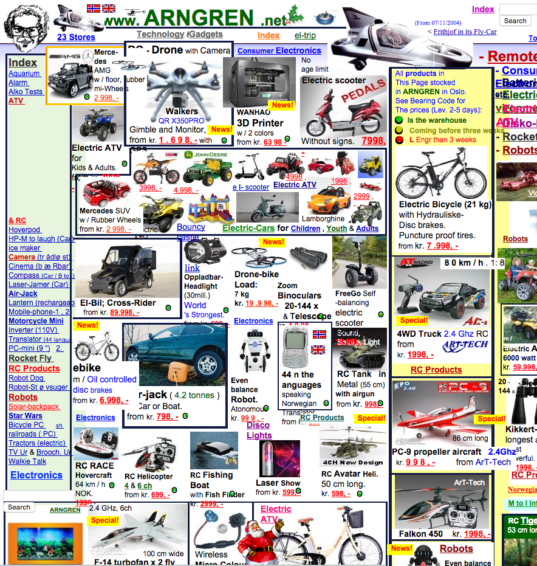

1. As far as well designed websites are concerned, <http://winspear.com.au/> is exceptional. This website was created for a hardwood flooring company. The layout is brutally simple. There are six clickable links on the menu bar that take you to other simple yet beautifully designed pages. The user always knows where they are and what they’re looking at. The pages here only show the user relevant information, which is a breath of fresh air on the web theses days. I have no need for hardwood flooring or related flooring products, but this website made me want to explore it anyway. The designer made perfect use of real estate and everything is white on black throughout. User effort here is at a minimum.

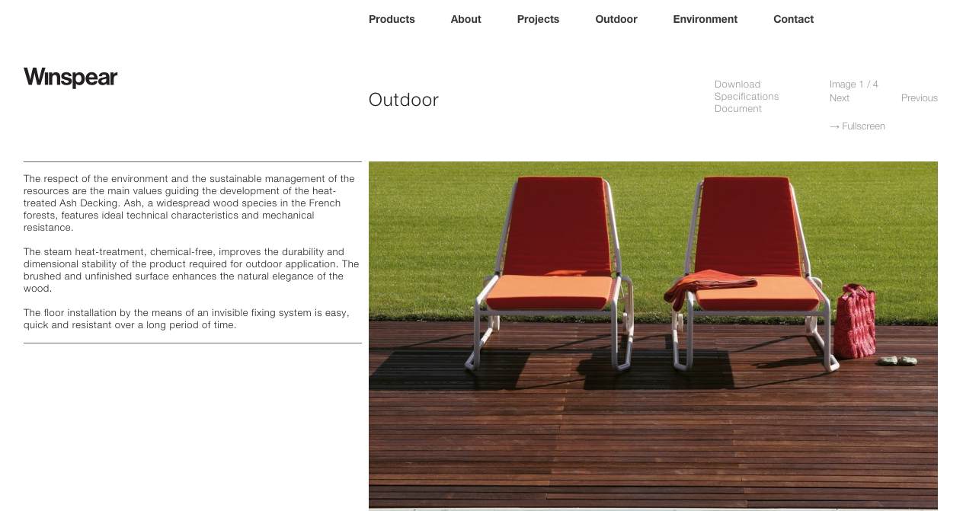

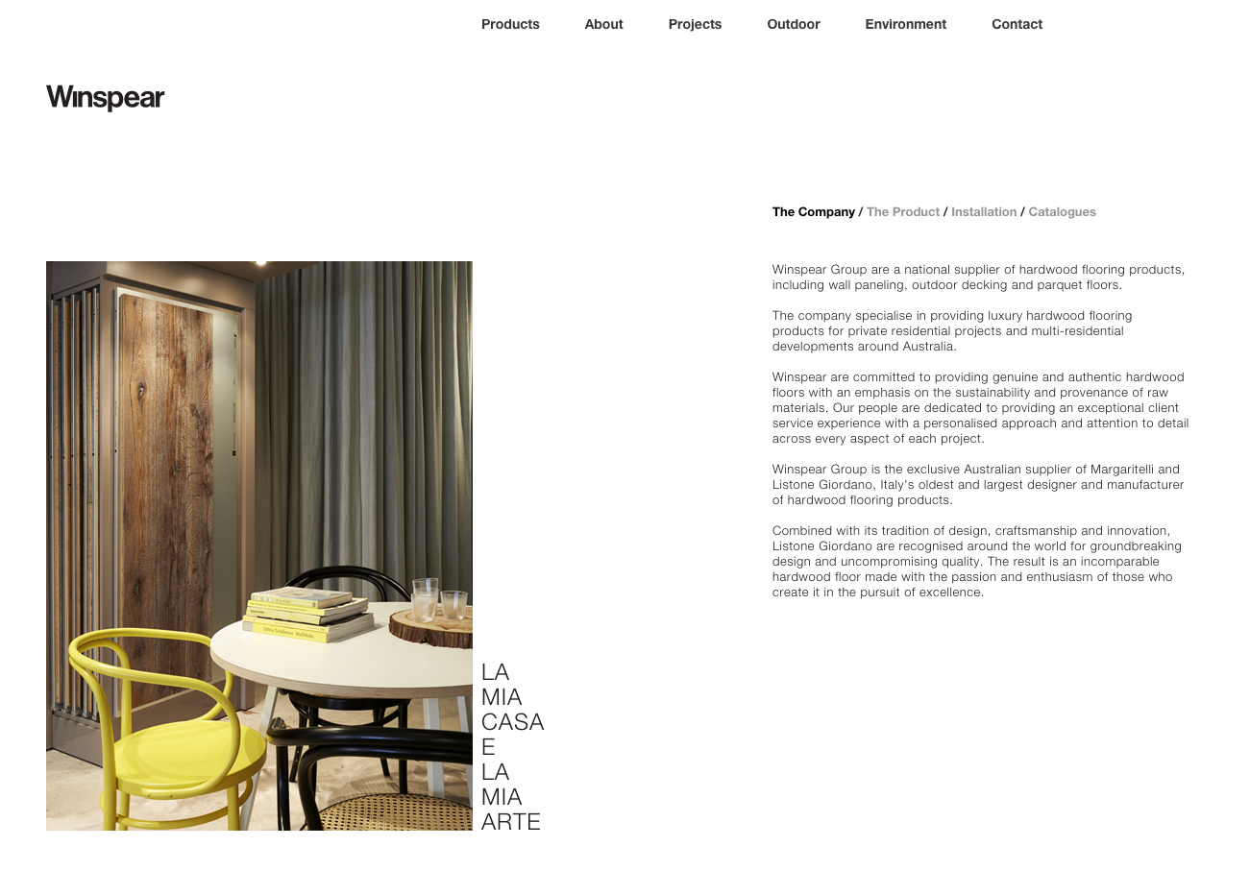

1. The <https://www.weber.edu/> website is very nice, especially in comparison with other colleges here in the state. The design is a little confusing however, there are links everywhere. Some of the links here are actually present in multiple locations across the page, although the designer made good use of the real estate. The site is consistent however, the top and bottom menus exist on every page, and the site has the same skin throughout. Thus, the site is mostly aesthetically pleasing. User effort is not as minimal as it could be, but this site is targeted for mostly computer savvy educated people. The thing that bothers me the most however, is the low resolution images. Many users have high resolution screens these days, and low resolution images (especially ones next to higher resolution objects/images) are quite the eye sore.

